dt: July 25, 2014,

modified August 8, 2014

fr: Rich Paschburg

su: Running BAT tests to Validate a Development Build

note: Need to know only. Users’ credentials are included.

-------------------------------------------------------------------------------------------------------------------------------

# Step 0: Update the appcache on each browser after a code update

Each time after a code update, you could be running with a new version of the Browser’s appcache. You should not start running any automated, or manual, tests until the appcache is up to date.

For each browser, before you run the tests, do the following:

* Navigate to the site, such as <http://jelly.mentoringmindsonline.com>
* Wait for a few minutes
* It is preferable to open the console to view activities.
  + In Chrome, you can right click on an element and choose Inspect Element. Then from the area that appears in the bottom of the page, choose Console.
  + Other browsers may have similar functionality. I see that Firefox has a tool to view the Web Console, but I am not sure if this is the correct console to use. In any case, it can be found at “Tools 🡪 Web Developer 🡪 Web Console”.
  + Wait for the activity to stop. You may see a “noupdate” after a refresh, indicating that all is ready.

Several minutes may be needed. If you do not wait long enough, you may be working with an incompatible mixture of old and new code.

This step is needed on each browser after a code update before doing manual or automated tests. If you clear the appcache, repeat this step.

# Start a remote desktop session with the AWS system that contains the test framework

I assume you are logged into a Windows system.

Click on the “Start” button at the lower left. (In Windows 8, I believe you do a Search from a charm at the right.)

Choose “mstsc” in the text box at the bottom. In the form that pops up, choose as the Computer: 54.255.188.247

The user is WIN-E321F67QVI\Administrator, but you just have to remember “Administrator”.

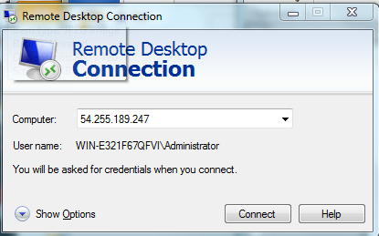

Hit Connect.

The Password is “Mentoring@Minds123”.

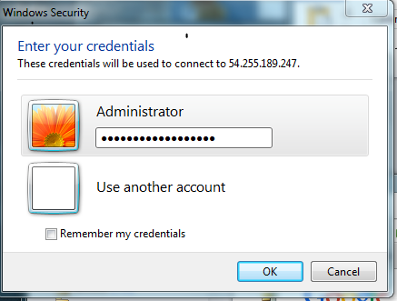

Hit OK. The following work is done on the Amazon AWS system. Note that only one person can have a Remote Desktop at a time. So only one person can be testing at a time using the Amazon AWS system.

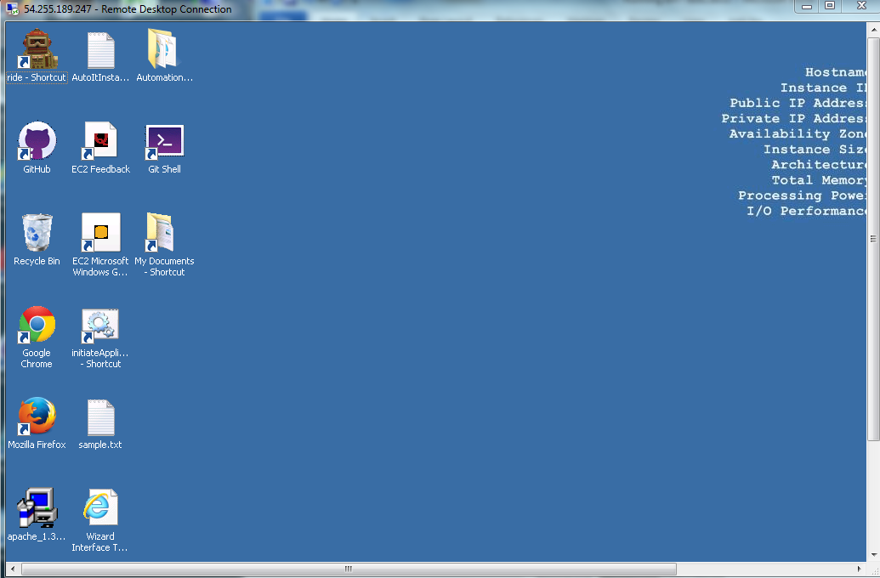

## Optional: To Get the Latest Code from GitHub

Start GitHub using the icon that is the second from the top of the left row. Double click, but then wait a long time.

Since Rafi Pathan was the first one to install the tests on the Amazon AWS system, I recommend you log in as him. If he is not already logged in, you use these credentials: user Rafikhan29, password R@f!kh@n29 (the symbol after the f is an exclamation point).

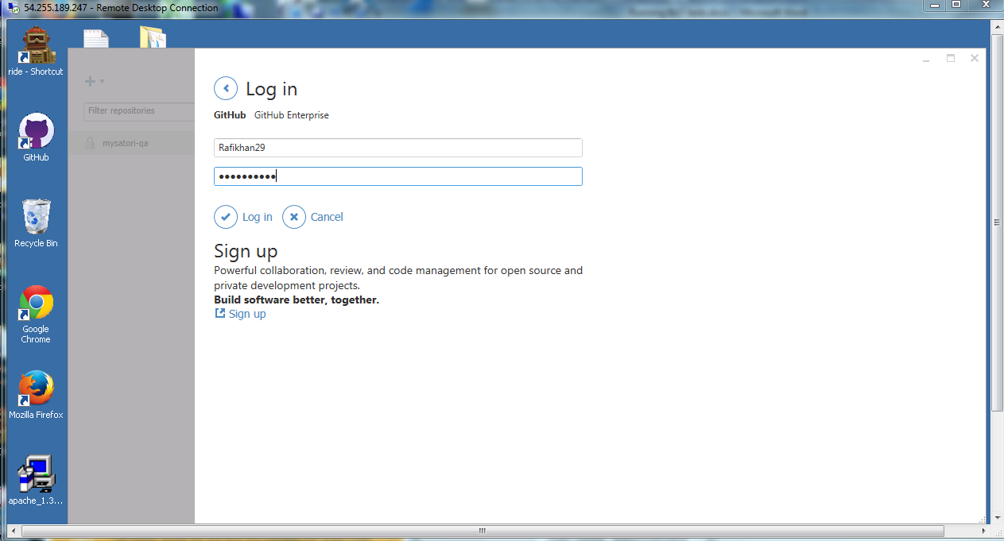

After you are logged in, or if Rafi was already logged in, you get a page similar to this:

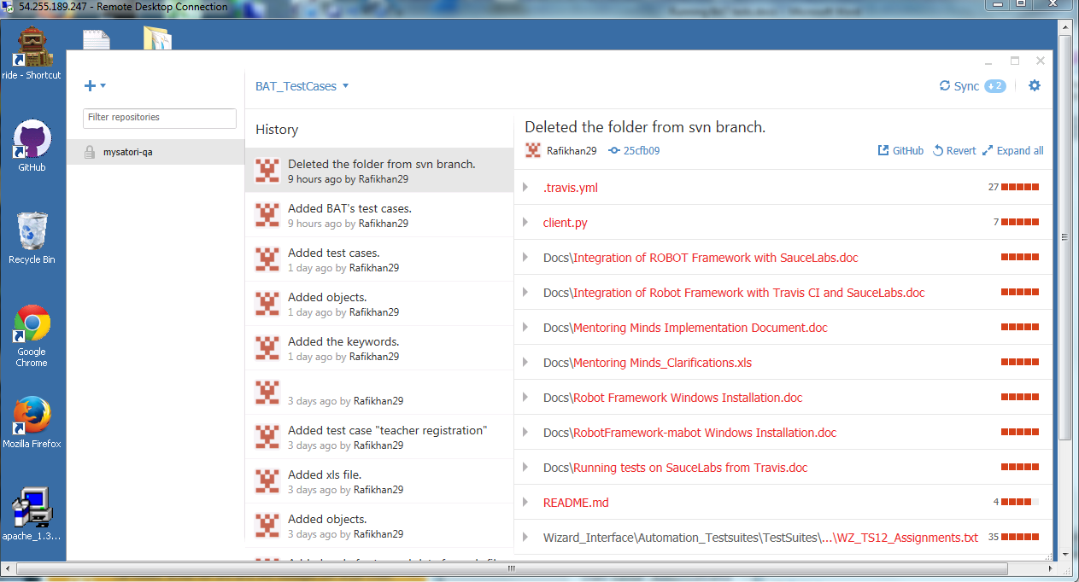

Note that at the upper left the branch is set to BAT_TestCases.

Note that at the upper right there is a Sync icon.

Click on the Sync icon to get the latest code from the BAT_TestCases branch of the repository.

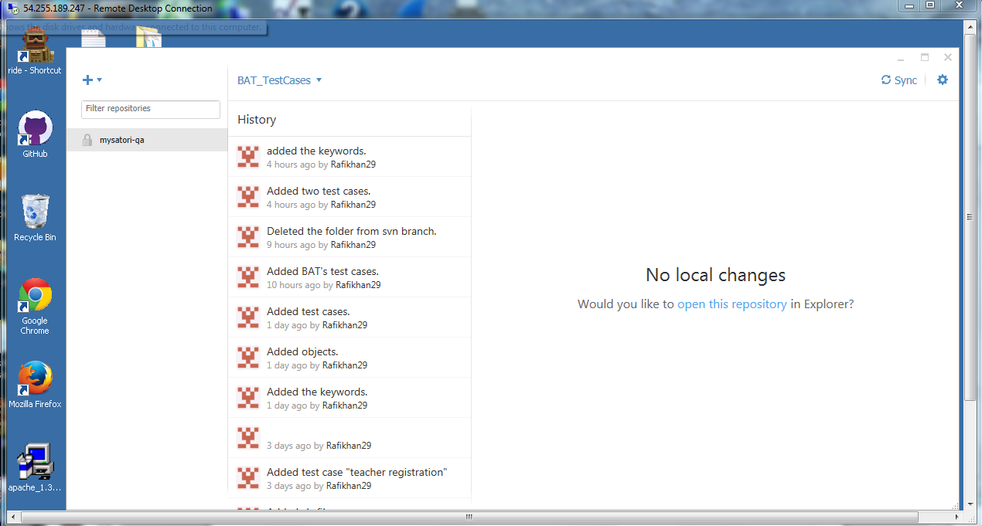

You can choose “Open In Explorer” from the Gear at the upper right.

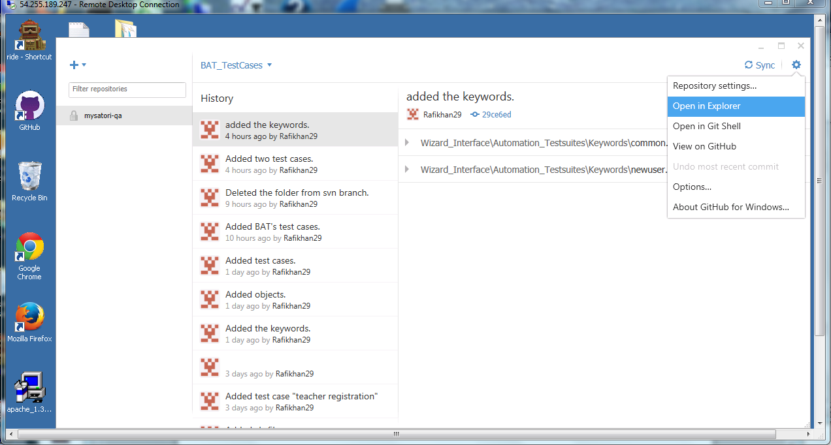

The resulting directory should be “C:\Mentoring_Minds\mysatori-qa”, which contains the Wizard_Interface folder. You can open that folder to note the dates.

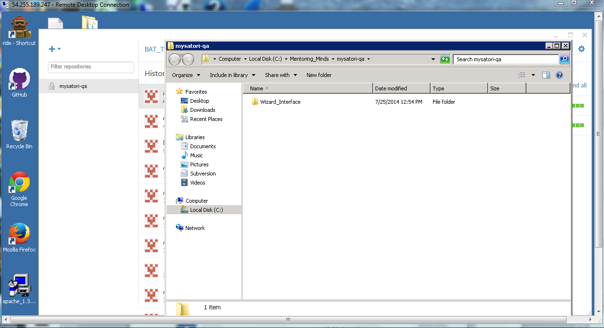

You do not need GitHub or the Windows Browser folder anymore, so you can close them.

## Launching the Test Framework

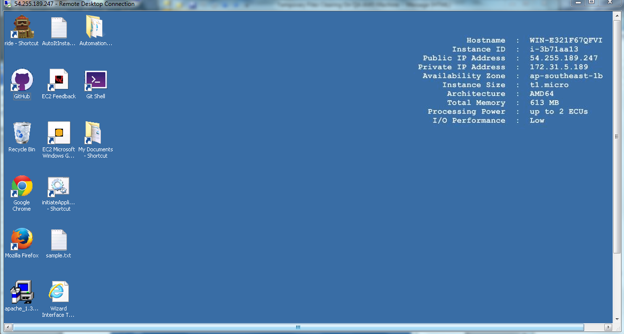

Click on the brown “Robot” icon at the upper left to run the Robot Framework IDE: RIDE.

The directory should already be correct.

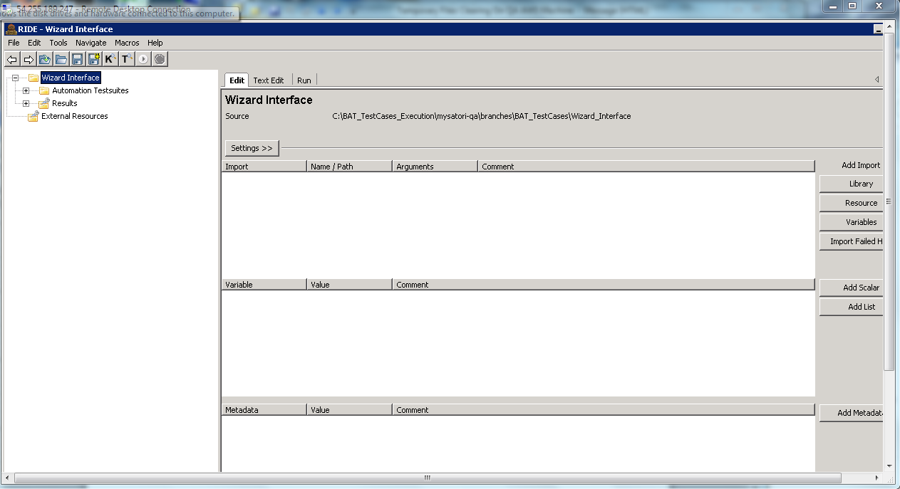

But if the file chosen is not correct, choose File 🡪 Open Directory. And then navigate to C:\BAT_TestCases_Execution\mysatori-qa-branches\BAT_TestCases\Wizard_Interface

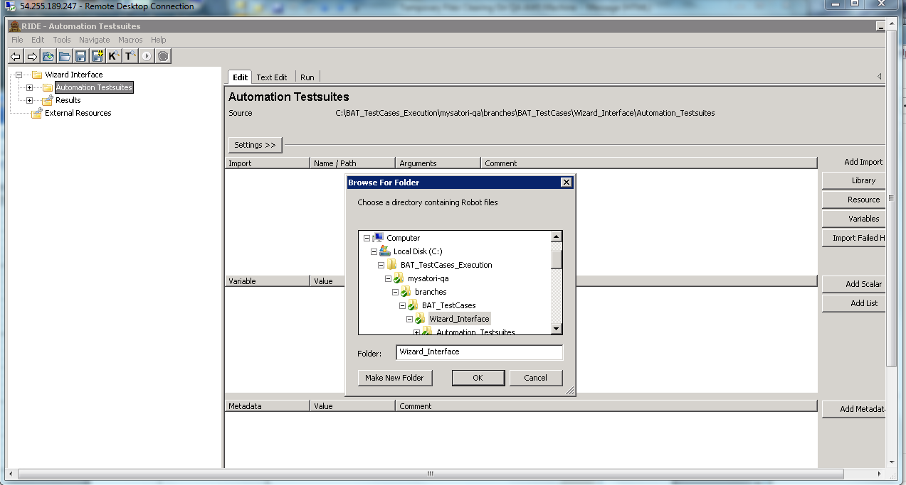

Click on OK to choose this set of tests.

Expand the uppermost “+” signs for Automation Test suites at the upper left until you get all the way down to the individual tests within “BAT Test Cases.

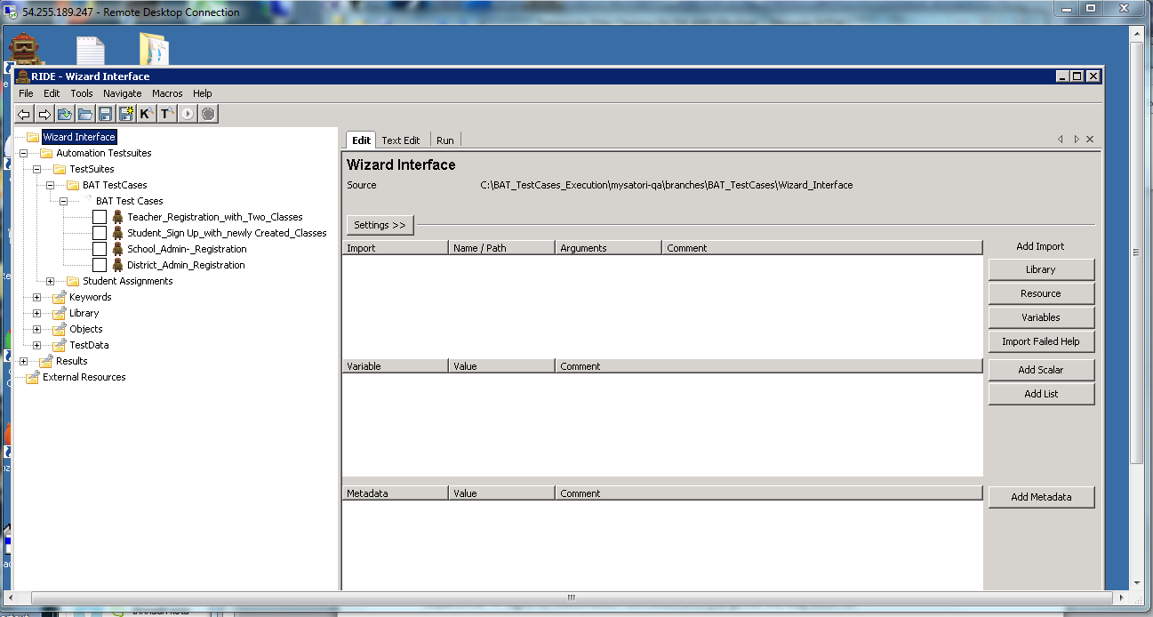

## To set the system under test to be the Development Release system

Expand the plus signs by Keywords 🡪 global.txt and choose ${WizardURL}. Within the list of scalars to the right, double click on the line starting with ${WizardURL}. A form appears to change the URL being tested.

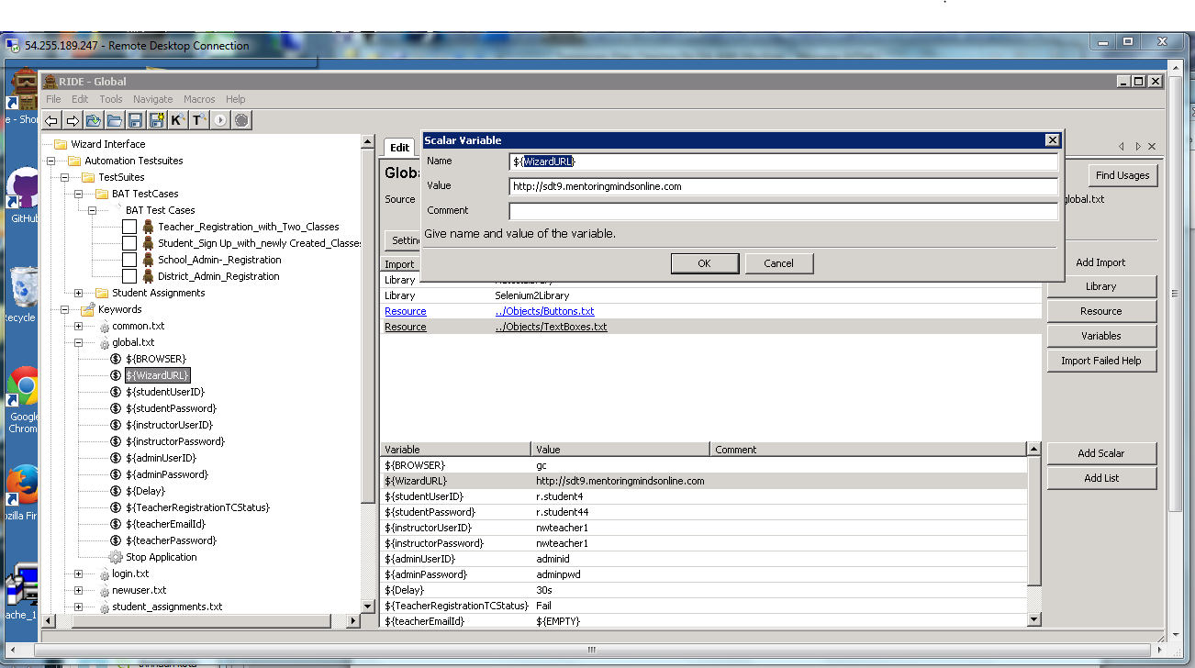

Note that the value recently used for QA is <http://sdt9.mentoringmindsonline.com>.

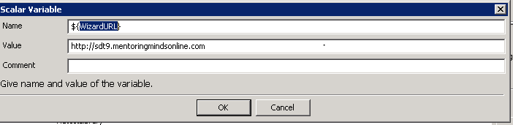

Over write the value with the Development Release URL to be tested. Choose OK.

Click on the floppy disk icon with a yellow plus sign, at the upper left of the page, to write your change to a file.

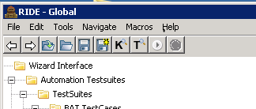

## Executing the Tests

Now return attention to the tests at the upper left part of the page. Place a checkmark in the first test, “Teacher_Registration_with_Two_Classes. Select the “Run” tab at the middle top of the page.

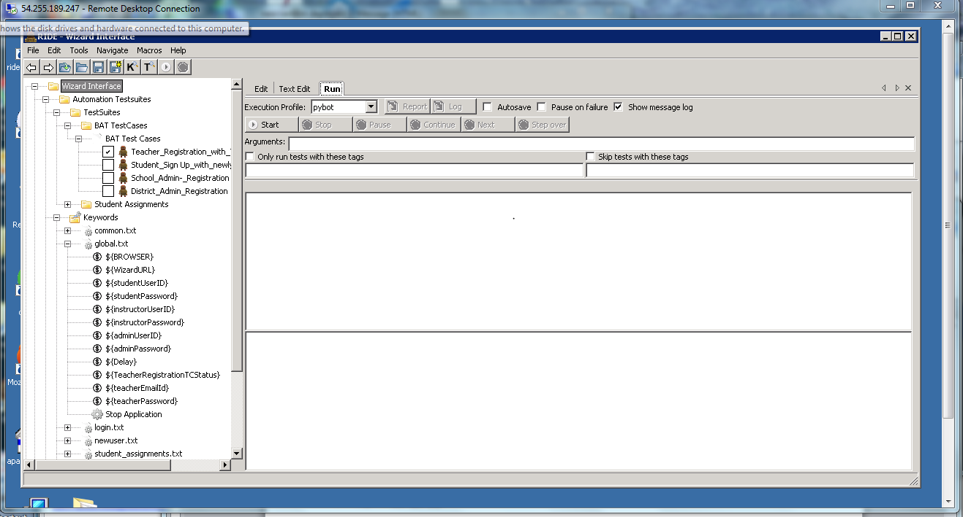

Click on “Start” just below and to the left of the Run tab.

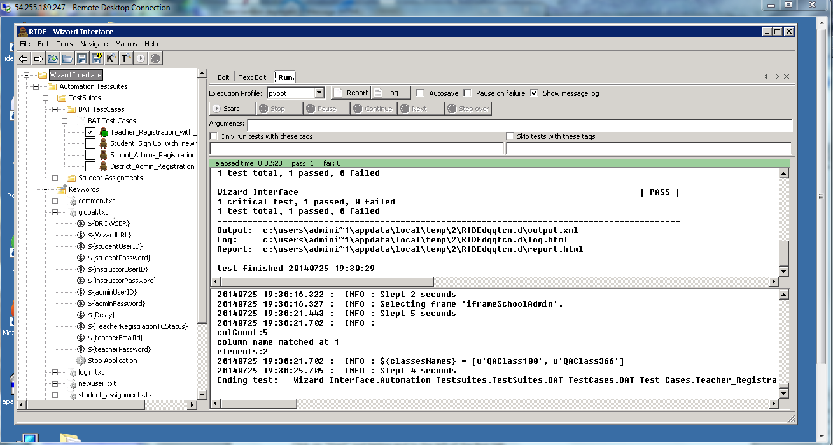

You will see the test run the Mentoring Minds site. If the test passes, there is a green bar at the top of the section with the log messages.

Next check all the boxes (all tests) and again RUN 🡪 START.

At the time this document is being written, the second test (adding a student) fails. The test does not do clean up, so you have to close the Mentoring Minds window.

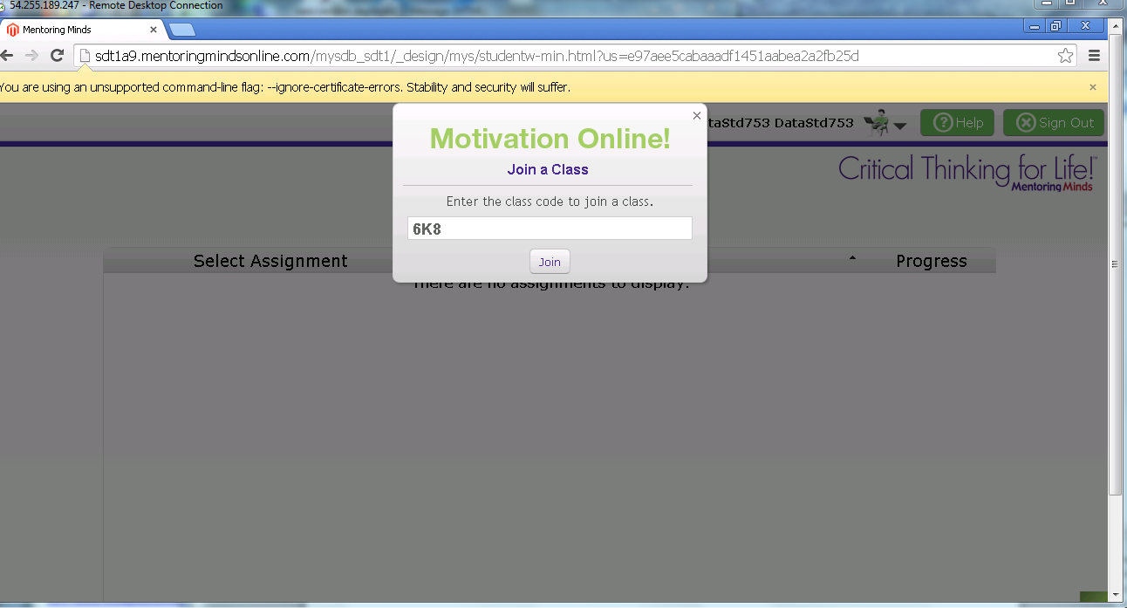

## Examining the Results

Return to RIDE. Since the test failed, there is a red bar along the top of the area where log entries appear.

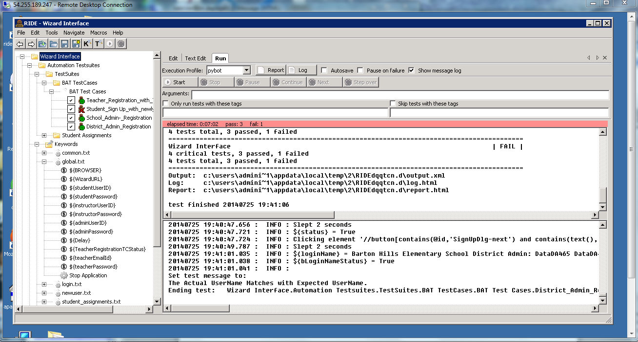

Click on Log.

An IE session opens up. The front page is a summary of the results: 4 tests run, 3 pass, 1 fail

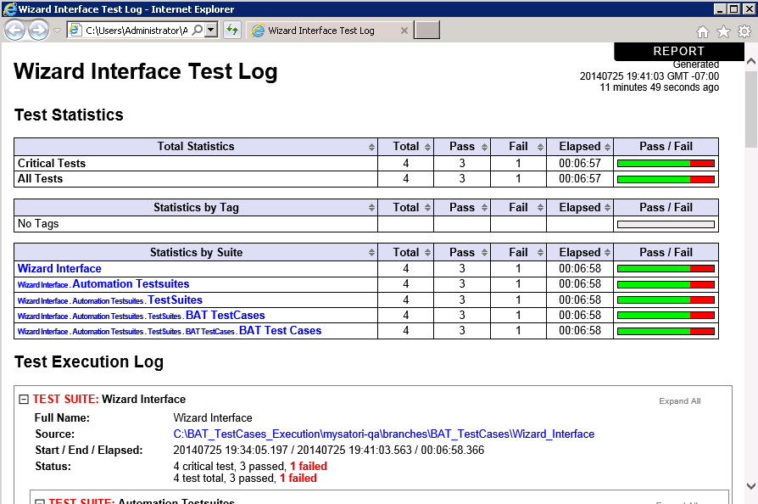

One test failed. And the failing keywords for the failed test are expanded. There is one keyword after the last failing keyword. In this case that keyword captures a screenshot. So expand the last keyword. The results at this time are:

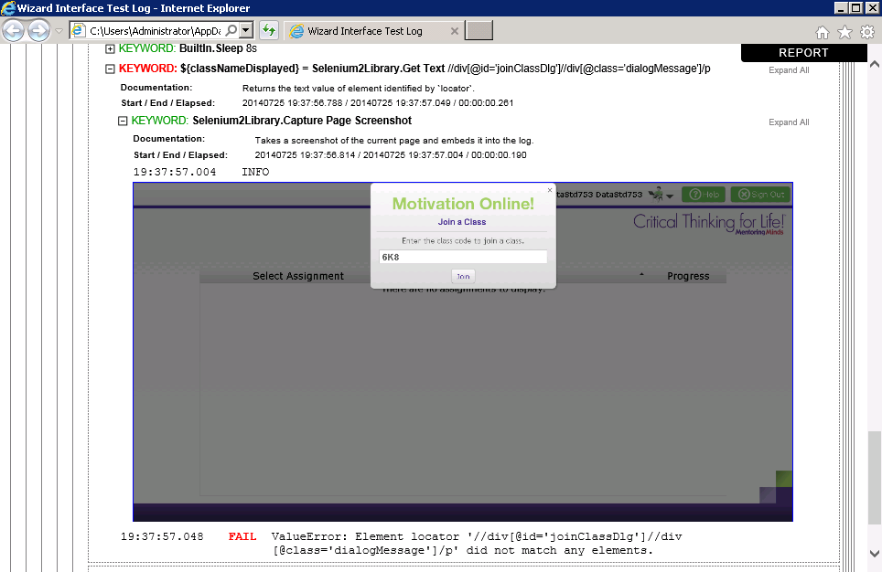

Some debugging is needed or perhaps a product problem was hit. But the system is not able to find the “locator” with the XPATH of “//div[@id='joinClassDlg']//div[@class='dialogMessage']/p”. As a result, the system never hit the Join button for the student to join the class.

## Conclusion

5 other BAT tests are planned for the initial set.

Let me know of any questions or issues.

Rich Paschburg

[rpaschburg@sdtcorp.com](mailto:rpaschburg@sdtcorp.com)

408-396-9928

Skype: richpaschburg